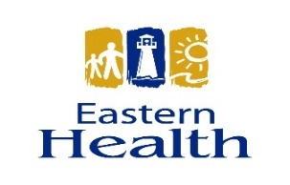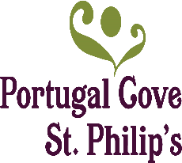
Primary Health Care

In Newfoundland and Labrador, primary health care is typically a person’s first point of contact with the health-care system.

Primary health care is a philosophy for organizing and delivering a comprehensive range of coordinated and collaborative community-based services that empower individuals, families and communities to take responsibility for their health and wellbeing. Effective primary health care requires a culture and system designed to be responsive to the needs and realities of individuals, families and local communities.

It encompasses a full range of community-based services essential to maintaining and improving health and wellbeing.
Primary health care is essential health care made accessible at a cost which the country and community can afford, with methods that are practical, scientifically sound, and socially acceptable.

Primary health care can include interactions with providers,
such as family doctors, pharmacists, social workers, nurses,
occupational therapists, counsellors, community volunteers
and others.

It includes services that promote health and wellness,
prevent illness, treat health issues or injuries, and diagnose
and manage chronic health conditions.

Eastern Health partnered with the Government of Newfoundland and Labrador Office of Public Engagement and the Town of Portugal Cove – St. Philip’s on 6, 7 and 8 March 2019 to host a series of community consultations on Primary Health Care in Portugal Cove- St. Philip’s. In total, four sessions were held, the first one at St. Philip’s Recreation Centre, followed by two in Portugal Cove at Murray’s Pond Fishing and Country Club and the final session held for the area’s senior’s group at the St. Philip’s Recreation Centre. The purpose of the sessions was to share information about health status of residents in the area, to engage participants in a discussion regarding health and together to search for concrete solutions to help transform primary health care in the Portugal Cove – St. Philip’s area.

Prior to starting the Community Advisory Committee and developing actions plans for the area, we would like to ensure we have provided opportunities for all community members to have their voice heard and therefore have developed a short survey which we ask that you take just a few moments to complete.

- What aspects of the Primary Healthcare System are working well in your community/region?

- What aspects of the Primary Healthcare System are NOT working so well in your community/region?

- What recommendations do you have for changing/improving the Primary Healthcare System in your area?

- Community involvement is important in creating a healthy and vibrant place to live and grow. What would make your community a healthier place to live?

- Do you have any additional comments you would like to make with regards to Primary Healthcare in your area?

PLEASE RETURN YOUR COMPLETED SURVEY TO THE TOWN HALL
DEADLINE FOR SURVEYS TO BE RETURNED IS 12 JUNE 2019.

Town of Portugal Cove - St. Philip's
1119 Thorburn Road Portugal Cove-St. Philip's, NL A1M 1T6
Thank you.

