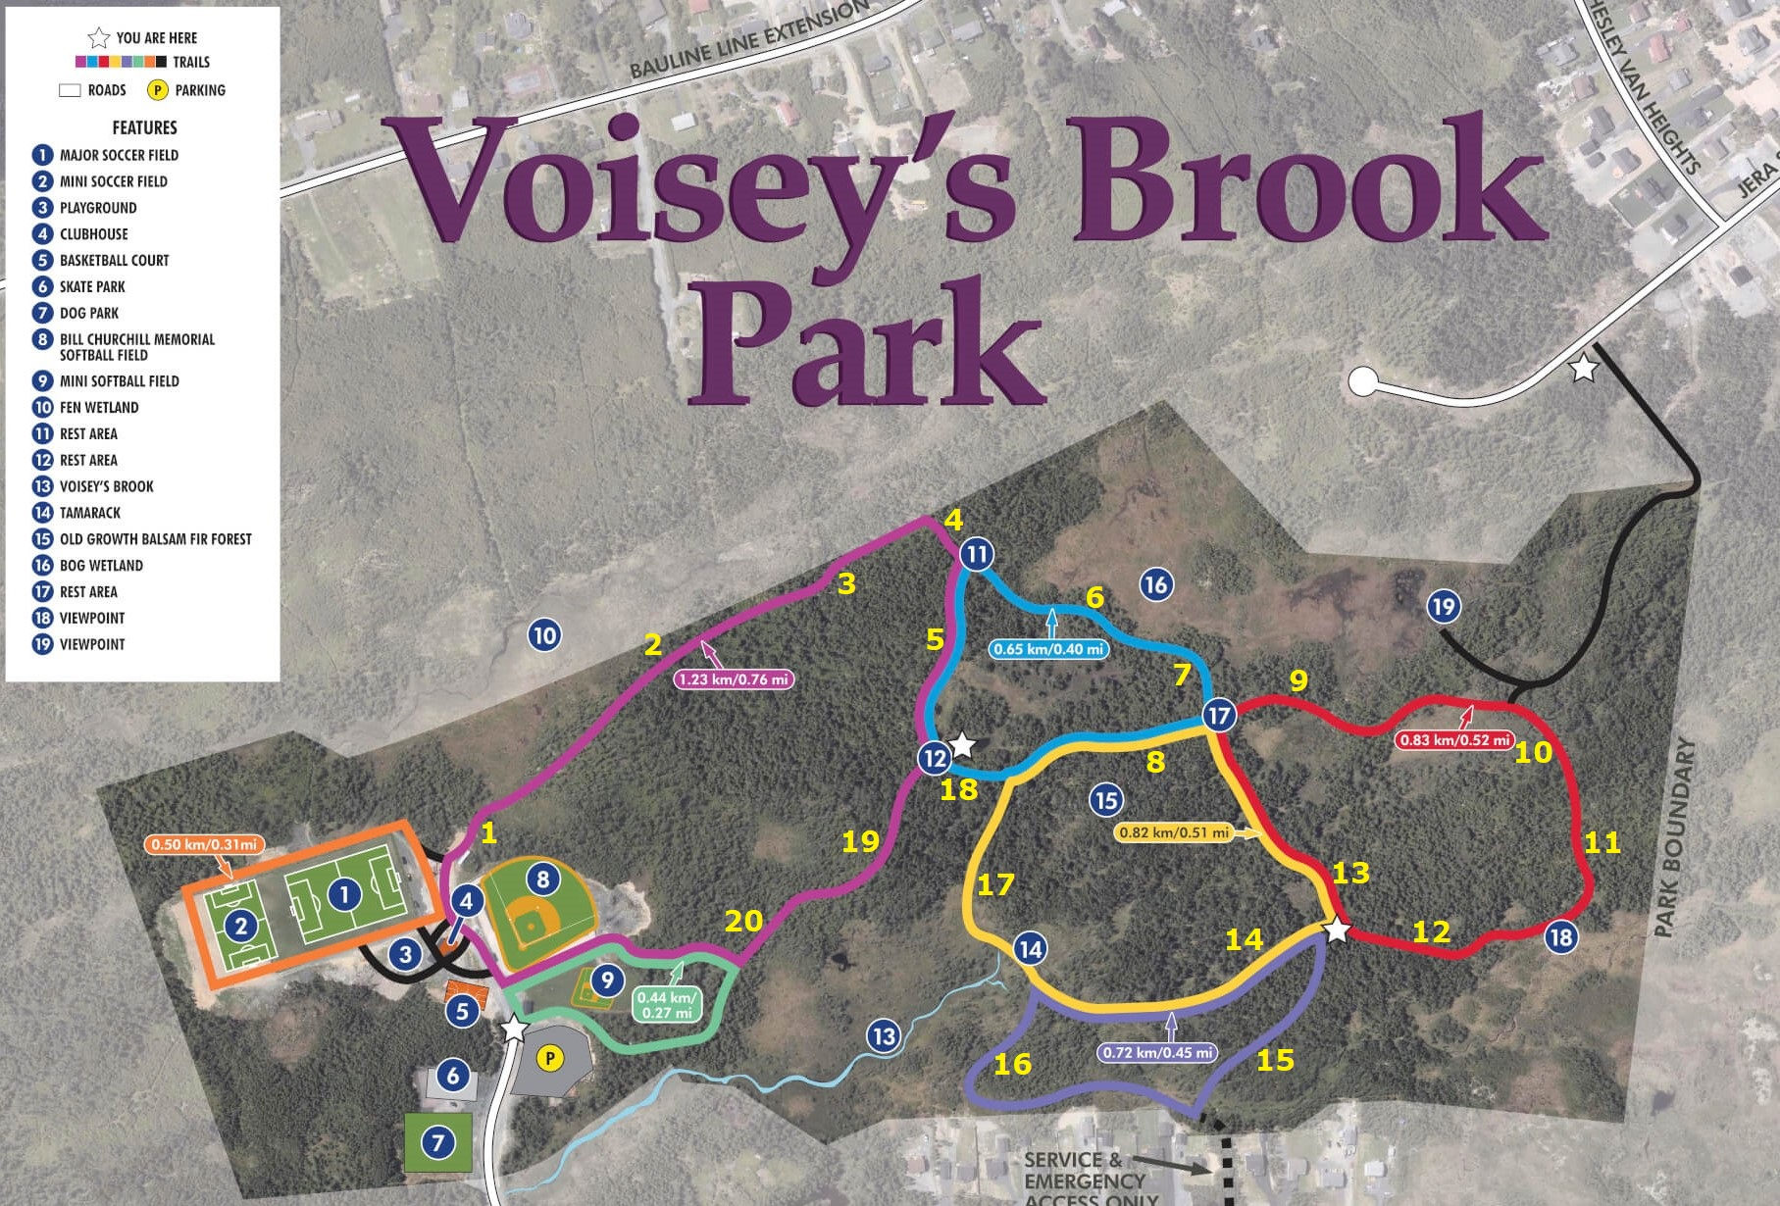
Portugal Cove – St. Philip’s Winter Orienteering Course

Description: Orienteering is an outdoor activity that challenges participants to use their navigation and map reading skills to find orienteering “signs” hidden throughout the trails. The “signs” are small pictures of animals attached on tree’s, the signs are no more than 5 feet from the trail and roughly 1-3 feet off the ground. Picture sizes range from the size of a cell phone to a normal sized reading book.

Objective: Locate all the orienteering signs in the park, each location is marked on the map with a number. Navigate to each location and correctly identify the animal on the picture and the corresponding number on the map. (ex. If there’s a beaver at location #8 write BEAVER next to #8 below).

Rules:
- Do not touch, take, or move signs please!
- All the signs are visible from the walking trail. Participants may walk off the trail to get a closer look at the pictures but we ask all participants to try and reduce our impact on the environment as much as possible.

Answers:

1. ____________________ 2. ____________________ 3. ____________________ 4. ____________________ 5. ____________________

6. ____________________ 7. ____________________ 8. ____________________ 9. ____________________ 10. ____________________

11. ____________________ 12. ____________________ 13. ____________________ 14. ____________________ 15. ____________________

16. ____________________ 17. ____________________ 18. ____________________ 19. ____________________ 20. ____________________

